Math 10

Lesson 2-2 Multiplying polynomials

Lesson Objectives:
a) You can use the distributive property to multiply polynomials. You multiply each term in the first polynomial by each term in the second polynomial.

Applying the distributive property/rule
The distributive property is:
a(b + c) = ab + ac
Examples are
40(20 + 6) = (40)(20) + (40)(6)
x(3x – 4y) = 3x² – 4xy

How can we use the distributive property to multiply two binomials like (x + 3)(x + 1)? Perhaps it would be instructive to first apply the distributive rule to a numerical example. Let’s multiply 42 by 26 using the distributive property.
(42)(26) = (40 + 2)(20 + 6)
= 40(20 + 6) + 2(20 + 6)
= 40(20) + 40(6) + 2(20) + 2(6)
= 800 + 240 + 40 + 12
= 1092
Now we can see how to multiply (x + 3)(x + 1)
(x + 3)(x + 1)
= x(x + 1) + 3(x + 1)
= x² + x + 3x + 3
= x² + 4x + 3

Algebra tiles
positive x-tile
positive x²-tile
positive 1-tile
For several weeks before teaching Math 10 I asked Math 10 graduates to share their opinions about algebra tiles. I discovered a polarity of opinion. Some found algebra tiles to be a powerful way to visualise and understand how binomials can be multiplied to form trinomials and how trinomials can be factored into binomials. Awesome!! On the other hand, many students said something like, “Learning to use tiles was the biggest waste of time.” Awesome!! Only a couple of people I spoke to were neutral about algebra tiles. Therefore, in this class I encourage you to use algebra tiles if you find them useful and to not use them if you find them useless.
negative x-tile
negative x²-tile
negative 1-tile

Example 2 Multiply the following binomials a) (x – 3)(2x + 1) b) (x – 2y)(x – 4y)

a) Method 1: Use Algebra Tiles
We can use algebra tiles to show the dimensions x – 3 and 2x + 1 and then complete the rectangle that has these dimensions. There are two x²-tiles, six negative x-tiles, one positive x-tile, and three negative 1-tiles in the rectangle. Therefore,
(x – 3)(2x + 1) = 2x² – 5x – 3.

Method 2: Use the Distributive Property
(x – 3)(2x + 1)
= x(2x + 1) – 3(2x + 1)
= (x)(2x) + (x)(1) + (–3)(2x) + (–3)(1)
= 2x² + 1x – 6x – 3
= 2x² – 5x – 3
b)
(x – 2y)(x – 4y)
= x(x – 4y) – 2y(x – 4y)
= x² – 4xy – 2xy + 8y²
= x² – 6xy + 8y²

Check: You can verify your work by substituting numerical values for the variables x and y. When checking, avoid using 0, 1 or 2. For example, substitute x = 5 and y = 3.
Left Side Right Side
(x – 2y)(x – 4y) x² – 6xy + 8y²
= [5 – 2(3)][5 – 4(3)] = (5)² – 6(5)(3) + 8(3)²
= (5 – 6)(5 – 12) = 25 – 90 + 72
= (–1)( –7) = 7
= 7
Left Side = Right Side

Question 1
Determine each product.
a) (x – 3)(x – 5) b) (5m – 1)(2m – 6)

Example 3 Multiply the following binomial and trinomial: (x + 2)(2x² – 5x + 1)

Multiply each term in the binomial by each term in the trinomial. Then, combine like terms.
(x + 2)(2x² – 5x + 1)
= x(2x² – 5x + 1) + 2(2x² – 5x + 1)
= 2x³ – 5x² + x + 4x² – 10x + 2
= 2x³ – x² – 9x + 2

Question 2
Determine each product.
a) (r – 4)(3r² + 8r – 6) b) (5x – 3)(2x² – 6x + 12)

Example 4 Simplify a) (x + 1)(5x + 3) + 3(2x + 4)(6x – 2)
b) (3w – 2)(4w + 5) – (w – 7)(2w + 3)
b) (3w – 2)(4w + 5) – (w – 7)(2w + 3)
= (3w)(4w + 5) + ( ̶ 2)(4w + 5) – [w(2w + 3) – 7(2w + 3)]
= 12w² + 8w – 8w – 10 – [2w² + 3w – 14w – 21]
= 12w² + 15w – 8w – 10 – 2w² – 3w + 14w + 21
= 10w² + 18w + 11

a)
(x + 1)(5x + 3) + 3(2x + 4)(6x – 2)
= x(5x + 3) + 1(5x + 3) + 3[2x(6x – 2) + 4(6x – 2)]
= 5x² + 3x + 5x + 3 + 3[12x² – 4x + 24x – 8]
= 5x² + 3x + 5x + 3 + 36x² – 12x + 72x – 24
= 41x² + 68x – 21

Question 3
Multiply and then combine like terms.
a) (x + 3)(5x – 2) + 4(x – 1)(2x + 5) b) 2(3x – 2) – (4x + 7)(2x – 5)

Question 4
When you have three factors, you can multiply in any order.
Multiply 3(2x + 4)(6x – 2) in three ways.

Question 5
The painting shown is Deep Magenta Square by Richard Anuszkiewicz. The length of the red square in the painting is unknown. The width of the border around the square is 30 cm.
a) What polynomial expression represents the total area of the painting?
b) What is the total area of the painting if the red square has an area of 3600 cm²?

Assignment
1. Multiply using algebra tiles (or not).
a) (x – 2)(x + 3)
b) (3x – 4)(2x – 1)
c) (x – 5)(x – 2)
d) (x + 3)²
e) (x + 4)(x + 7)
f) (2x – 5)(x – 3)

2. Multiply using the distributive property.
a) (x + 5)(x – 2)
b) (x – 3)²
c) (c – d)(c + d)
d) (4x + y) (x + y)
e) (y + 3) ²
f) (4j + 2k)(6j – 3k)

3. Use the distributive property to determine each product.
a) x(3x² – 5x + 8)
b) a(7b² + b – 1)
c) (x – 3)(6x² – 4x – 12)
d) (2x – 1)(5x² + 4x – 5)
e) (4s² + s)(3s² – 2s+ 6)
f) (2y² + 3y – 1)(y² + 4y + 5)

4. Match each binomial multiplication on the left with a trinomial on the right.
a) (x + 1)(x – 2) A x² + 13x + 36
b) (x – 3)(x – 4) B x² – x – 2
c) (x – 1)² C x² – 2x – 1
d) (x + 4)(x – 3) D x² + x ̶ 12
e) (x ̶ 3)(x ̶ 5) E x² + 6x + 9
f) (x + 3)² F x² ̶ 2x + 1
g) (x + 9)(x + 4) G x² ̶ 9x + 18
h) (x – 6)(x – 3) H x² ̶ 7x + 12
I x² – 7x – 12
J x² – 8x + 15

5. Multiply. Then, combine like terms.
a) (4n + 2) + (2n – 3)(3n – 2)
b) (f + 7)(2f – 4) – (3f + 1)²
c) (b – 2d)(5b – 3d) + (b + d)(4b + d)
d) (4x – 2)(3x – 5) + 2(7x + 5)(2x – 6)
e) 3(5a + 3c)(2a – 3c) – (4a + c)²
f) (y² – 5y – 6)(4y² + 6y + 1)

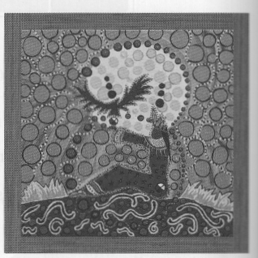
6. The painting shown is by Metis artist Leah Marie Dorion from Prince Albert, Saskatchewan. It is called Hawk Woman (2006). The frame is 2 in. wide on each side of the square painting. Write an expression to represent the dimensions and area of the painting. Multiply, and then combine like terms.

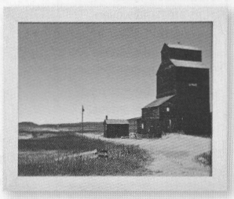
7. Darien trimmed a square photo to fit into a rectangular frame. He cut 7 cm from one side and 4 cm from the other. Let x represent the side length of the original square photo. Write an expression for the area of the trimmed photo. Multiply, and then combine like terms.

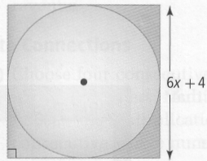
8. A circle is inset into a square with a side length of 6x + 4, as shown. Write an expression to represent the area of the circle. Multiply, and then combine like terms.

9. Bryan was asked to multiply two binomials. He completed the following work.
(p + 3)(p + 7) = p² + 7p + 3p + 21 Step 1
= p² + 10p + 21 Step 2
= 11p² + 21 Step 3
a) Is Bryan's work correct? If not, which step is incorrect?
b) Choose any number for p. Determine whether the following equation is true.
(2p – 3)(p + 4) = 2p² – 5p – 12

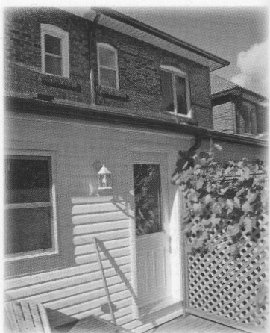
10. The Li family has a house with a length of 13 m and a width of 9 m. Due to lot restrictions; they can make an addition of only y metres to the width and x metres to the length.
a) Sketch a diagram of the area of the house. Label the dimensions.
b) Write an expression for the area of the house, including the addition.
c) Calculate the area if x = 1 m and y = 2 m.

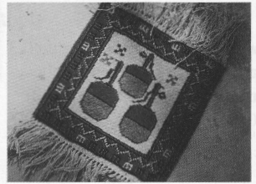
11. Susan is making a rectangular area rug with a similar design to the square rug she made earlier.
a) What are the dimensions if the new rug is 2 ft longer and 1 ft narrower than the square rug?
b) Write an expression for the area of the new rug.
c) If the square rug is 3 ft by 3 ft, which rug has the greater area? Show your work.

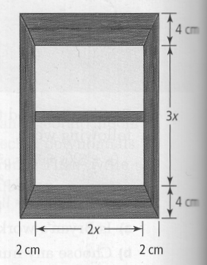
12. Vera is installing a kitchen window that has a height-to-width ratio of 3:2. The window frame adds 4 cm to the width and 8 cm to the height.
a) Write a polynomial expression that represents the total area of the window, including the frame. Multiply and combine like terms.
b) Calculate the area when x = 12 cm.

13. Andre multiplied the expression (2x – 4)(3x + 5). When he checked his answer, he discovered an error.
(2x – 4)(3x + 5) = 2x(3x + 5) – 4(3x + 5)
= 6x² + 10x – 12x + 20
= 6x² – 2x + 20
Check:
Let x = 4.
Left Side Right Side
(2x – 4)(3x + 5) 6x² – 2x + 20
= [2(4) – 4][3(4) + 5] = 6(4)² – 2(4) + 20
= [8 – 4][12 + 5] = 96 – 8 + 20
= [4][17] = 108
= 68
a) Explain how Andre knew that he had made an error.
b) Explain the error and how to correct it.

14. The average number of burgers, b, sold at The Burger Barn daily can be represented by b = 550 – 100p, where p is the price of a burger, in dollars.
a) How does the average number of burgers sold change as the price of a burger increases?
b) Solve the equation for p.
c) The revenue from burger sales can be represented by R = np, where R is the total revenue, in dollars, and n is the number of burgers sold. Substitute your expression for p from part b). Then, multiply to get an expression for the daily burger revenue.

